

**Palestine Technical University-Kadoorie**

Computer Systems Engineering Department

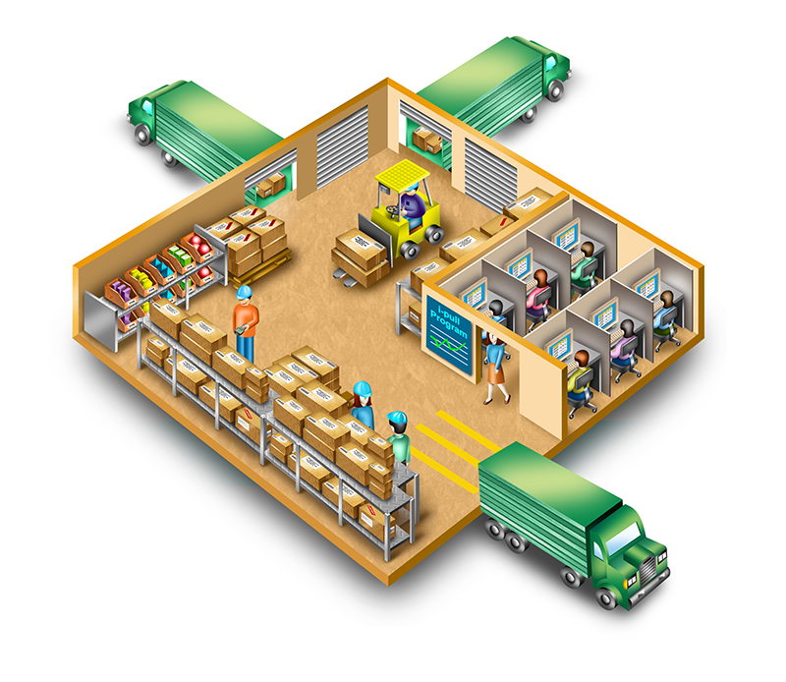

**A Warehouse Management System**

**Prepared by:**

Yousef Jaber (202110266)

Ahmad Tomeh (202110060)

Yazan Hussien (202112844)

Yaseen Ashqar (202110871)

**Supervisor:**

Dr. Osama Hamed

**Abstract:**

This project introduces a sophisticated Warehouse Management System (WMS) designed to meticulously track inbound and outbound inventory movements, monitor stock levels, manage expiration dates, and advance reservation for warehouses ,easy access to the storage with financial reports.

The system offers real-time visibility into inventory flows, ensuring accurate records of goods entering and leaving the warehouse. Additionally, it includes features to monitor and prevent stock from expiring, minimizing wastage and maximizing profitability. By integrating payment methods, the system facilitates seamless transactions, enhancing operational efficiency. Through this comprehensive approach, the WMS optimizes inventory control, mitigates losses due to expiration, and streamlines financial processes, ultimately bolstering warehouse operations.

**1 . INTRODUCTION**

This project introduces a sophisticated Warehouse Management System (WMS) designed to meticulously track inbound and outbound inventory movements, monitor stock levels, manage expiration dates, and streamline payment methods with easy access to the storage

The system offers real-time visibility into inventory flows, ensuring accurate records of goods entering and leaving the warehouse. Additionally, it includes features to monitor and prevent stock from expiring, minimizing wastage and maximizing profitability. By integrating payment methods, the system facilitates seamless transactions, enhancing operational efficiency. Through this comprehensive approach, the WMS optimizes inventory control, mitigates losses due to expiration, and streamlines financial processes, ultimately bolstering warehouse operations

**1.1 Purpose**

The purpose of this document is to build an online system to manage the warehouses and track inbound and outbound inventory to ease access to the storage.

**1.2 DOCUMENT CONVENTIONS**

This document uses the following conventions.

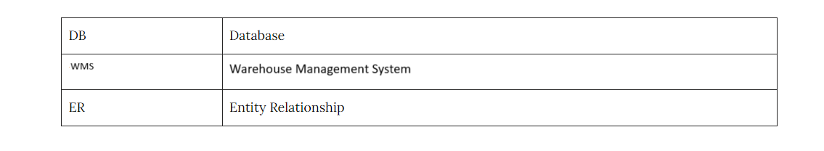

**1.3 INTENDED AUDIENCE AND READING SUGGESTIONS**

This project is a prototype for the warehouse management system and it is restricted within the college premises. This has been implemented under the guidance of college professors(**Dr. Osama Hamed**)

This project is useful for the large companies that have very large storage spaces that and as well as to the shop owners

**1.4 PROJECT SCOPE**

The purpose of the online warehouse management system is to ease manage the warehouses and track inbound and outbound inventory to ease access to the storage and to create a convenient and easy-to-use application for shop owner to request an order and know my estimated time of arrival.

The system is based on a relational database with its warehouse management and functions to control the outbound ,inbound and storage.

We will have a database server supporting thousands of types of goods, that is available in Palestine . above all, we hope to provide a comfortable a user experience along with the best pricing available and accurate timing.

* 1. **REFERENCES**
* <https://krazytech.com/projects>
* Software Engineering 9th Edition by Ian Sommerville

## 2. OVERALL DESCRIPTION

**2.1 PRODUCT PERSPECTIVE**

* The Warehouse Management System (WMS) is designed as an integrated part of a broader supply chain management ecosystem. It interfaces with procurement, inventory management, order fulfillment, and shipping modules, providing seamless coordination and efficient management of warehouse operations. The system serves as a centralized platform that supports real-time tracking, management, and reporting of warehouse activities.

**2.2 PRODUCT FEATURES**

**Inventory Management:**

* + Real-time tracking of inventory levels, automated stock replenishment, and inventory auditing.

**Order Processing:**

* + Efficient order picking, packing, and shipping processes, including batch processing and prioritization of urgent orders.

**Receiving and Put away:**

* + Streamlined processes for receiving shipments and organizing inventory in optimal storage locations.

**Barcode/RFID Integration:**

* + Support for barcode and RFID scanning to improve accuracy and speed of operations.

**Reporting and Analytics:**

* + Comprehensive reporting tools and analytics for performance monitoring, trend analysis, and decision support.

**User Access Control:**

* + Role-based access control to ensure users only access functions relevant to their roles.

**Alerts and Notifications:**

* + Automated alerts and notifications for critical events such as low stock levels, order delays, and equipment failures.

**2.3 USER CLASS and CHARACTERISTICS**

* Warehouse Managers:
  + Responsibilities: Oversee overall warehouse operations, make strategic decisions, and generate performance reports.
  + Access: All system functionalities and analytics.
* Inventory Controllers:
  + Responsibilities: Maintain optimal inventory levels, conduct audits, and generate inventory reports.
  + Access: Inventory management and reporting features.
* Order Fulfillment Staff:  
  + Responsibilities: Pick, pack, and ship orders.
  + Access: Order processing and barcode/RFID scanning functionalities.  
    - * Receiving Staff:  
        + Responsibilities: Handle incoming shipments, inspect goods, and manage put-away operations.
        + Access: Receiving, put-away, and barcode/RFID scanning features.

IT Administrators:

Responsibilities: Maintain system infrastructure, manage user permissions, and handle integrations.

Access: Administrative access to all system settings and configurations.

Executives:

Responsibilities: View high-level performance metrics and reports.

Access: Dashboards and analytics features.

**2.4 OPERATING ENVIRONMENT**

**2.5 DESIGN and IMPLEMENTATION CONSTRAINTS**

**The system must adopt a modular architecture to ensure flexibility and scalability. Each module, such as inventory management and order processing, should function independently while integrating seamlessly with others. It must support both on-premise and cloud-based deployment options to cater to different organizational preferences and requirements.**

* **User Interface:**
  + The interface should be intuitive and user-friendly to minimize the learning curve for users. Consistency in design and navigation is critical.
  + A responsive design is necessary to ensure usability across various devices, including desktops, tablets, and smartphones.

**Data Management:**

The system should support high-volume transactions and large datasets typical in warehouse operations. Efficient database design and indexing are crucial for performance.

Data redundancy and replication strategies must be employed to ensure data integrity and availability.

## 

## 5. NONFUNCTIONAL REQUIREMENTS 5.1 PERFORMANCE REQUIREMENTS

## A) E-R DIAGRAM

## 

## 5.2 SAFETY REQUIREMENTS

**5.2.1 Data Integrity**

## Financial Reports Table

## Implement data validation checks to ensure that revenue, expenses, and profit values are within acceptable ranges and formats.

## Enforce referential integrity constraints to maintain consistency between financial reports and associated data.

## Users Table

## Implement mechanisms to prevent duplicate usernames and ensure uniqueness of user accounts.

## Regularly validate and sanitize user input to prevent SQL injection attacks and other forms of data manipulation.

## Reservations Table

## Validate reservation dates to prevent overlaps and conflicts with existing reservations.

## Customers Table

## Enforce uniqueness of customer IDs and email addresses to prevent duplicate customer accounts.

## Implement validation checks to ensure the correctness of customer data entered into the system.

## Warehouse Table

## Validate section capacity values to ensure they are realistic and within acceptable limits.

## Employees Table

## Implement validation checks to ensure the correctness of employee data entered into the system.

## Mechanisms Table

## Validate mechanism prices to prevent negative or unrealistic values.

## Access Controls

## Enforce least privilege principles to ensure that users only have access to the data and functionalities necessary for their roles.

* 1. **SECURITY REQUIREMENTS**

**These security requirements aim to protect the confidentiality, integrity, and availability of data stored in the database and ensure compliance with regulatory requirements. Implementing these measures will help mitigate security risks and safeguard sensitive information against unauthorized access and malicious activities.**

* + 1. **Access Control**

1. **Financial Reports Table**

* Only authorized users with appropriate roles (e.g., finance manager) shall have access to financial reports data.

1. **Users Table**

* Enforce access control measures to ensure that only authenticated users can access the Users table.

1. **Reservations Table**

* Access to reservation data shall be restricted to authorized users such as warehouse managers and customer service representatives.

1. **Customers Table**

* Protect customer data by enforcing access control measures and encrypting sensitive information such as passwords and email addresses.

1. **Warehouse Table**

* Access to warehouse section data shall be restricted to authorized personnel such as warehouse managers and supervisors.

1. **Employees Table**

* Secure employee data by enforcing access control measures and encrypting sensitive information such as employee names and contact details.

1. **Mechanisms Table**

* Access to mechanism data shall be restricted to authorized users such as inventory managers and procurement officers.
  + 1. **Authentication Mechanisms**
* Implement secure authentication mechanisms, such as username/password authentication .
  + 1. **Data Encryption**
* Implement encryption mechanisms to protect sensitive data stored in the database, such as passwords, email addresses, and financial information.

**5.4 Software Quality Attributes**

## Availability

## Data in the database should be available when needed, especially for critical operations such as reservations.

## Application to the Database:

## Implement measures such as redundancy, load balancing, and failover to ensure continuous availability of data.

## Correctness

## Enforce data integrity constraints to maintain data consistency and accuracy.

## Validate input data to ensure that it meets specified criteria and prevent data errors or inconsistencies.

## Maintainability

## Implement version control for database schema changes and document database updates to ensure traceability and ease of maintenance.

## Usability

## The database system should be user-friendly and accessible on multiple devices to cater to a diverse user base.

## Ensure compatibility with various devices and screen sizes by implementing responsive design principles for web-based interfaces.

## GitHup resp: [Warehouse-management-system](https://github.com/ahmadtomeh03/Warehouse-management-system)